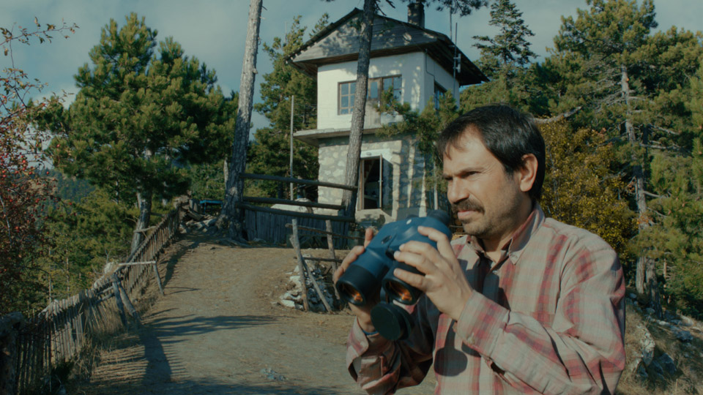
Get ready for Houston's first Turkish Film Festival!
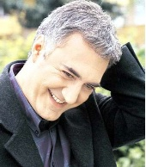  Top: Still from Watchtower  Above: Tamer Karadagli  Tamer Karadagli is an acclaimed, popular Turkish actor who has worked extensively in film and television. Following the screening, there will be a brief question-and-answer session in the theater with special guest, Mr. Tamer Karadagli. Afterwards the audience is invited to a reception in the museum galleries, hosted by the Consulate General of Turkey.  Houston Turkish Film Festival Committee: The Honorable Cemalettin Aydin, Consul General of Turkey in Houston; Cenk Ozdogan, Jaleh Sallee, Tayfun Karakoc, Derya Baysal, Dilsat Baysal, Franci Crane, Ayse Mccracken, and Hande Castiglioni.  Special thanks to Mehmet Altioklar, Erkut Gomulu, and Ayca User for their programming assistance.  The MFAH film department is supported by Tenaris; The Academy of Motion Picture Arts and Sciences; Nina and Michael Zilkha; the National Film Preservation Foundation; Franci and Jim Crane; James V. Derrick; Ms. Melanie Gray and Mr. Mark Wawro; and Lynn S. Wyatt.  Special Ticket Prices Apply! Individual tickets are $10. MFAH Members, senior adults, and students with ID receive a $2 discount on tickets. | April 5–7, 2013  1st Houston Turkish Film Festival  Responding to the enthusiastic reception for Turkish films screened at the MFAH in recent years (including Once Upon a Time in Anatolia and Three Monkeys,) the museum presents this inaugural festival showcasing the talent and diversity that characterizes Turkey's contemporary cinema. The programming includes a special appearance by renowned actor Tamer Karadagli, two acclaimed first features, an acclaimed documentary about Turkish music, and other selections. All films are in Turkish with English subtitles.  SHATTERED SOUL (BEYZA´NIN KADINLARI)  Directed by Mustafa Altioklar  (Turkey, 2006, 137 min.)  Friday, April 5, 7 p.m.  In person: actor Tamer Karadigli  TOLL BOOTH (GISE MEMURU)  Directed by Tolga Karaçelik  (Turkey, 2010, 96 min.)  Saturday, April 6, 5 p.m.  LOST SONGS OF ANATOLIA (ANADOLU´NUN KAYIP SARKILARI)  Directed by Nezih Unen  (Turkey, 2010, 96 min.)  Saturday, April 6, 7 p.m.  THE EXTREMELY TRAGIC STORY OF CELAL TAN AND HIS FAMILY (CELAL TAN VE AILESININ AÞIRI ACIKLI HIKAYESI)  Directed by Onur Ünlü  (Turkey, 2011, 98 min.)  Saturday, April 6, 9 p.m.  POLLUTING PARADISE (DER MÜLL IM GARTEN EDEN)  Directed by Fatih Akin  (Germany/Turkey, 2012, 93 min.)  Sunday, April 7, 3 p.m.  WATCHTOWER (GOZETLEME KULESI)  Directed by Pelin Esmer  (Turkey/Germany/France, 2012, 100 min.)  Sunday, April 7, 5 p.m.  LOVE LIKES COINCIDENCES (ASK TESADUFLERI SEVER)  Directed by Ömer Faruk Sorak  (2011, Turkey, 118 min.)  Sunday, April 7, 7 p.m.  Click here for film descriptions and to purchase tickets.

__._,_.___

__,_._,___

